FOR IMMEDIATE RELEASE

Media Contact:
Madelynne Pursglove
856-283-9840
audubongreenteam@gmail.com
sustainableaudubon.com

AUDUBON GOES SMOKE FREE.
Sustainable Audubon committee acts to reduce air pollution and tobacco waste.
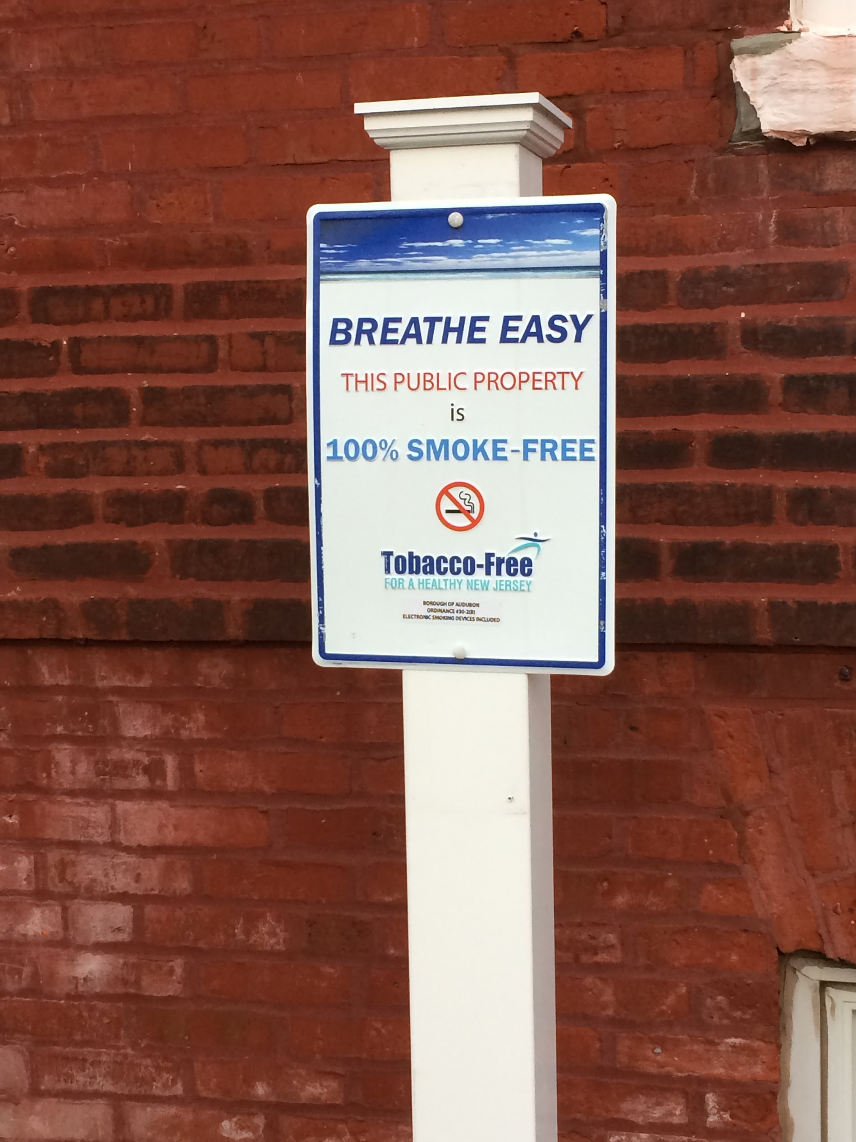
AUDUBON, March 8, 2018-- On August 15, 2017, Audubon adopted ordinance 2017-04, banning smoking in all public parks and recreation facilities owned or leased by the Borough of Audubon.

It’s no secret that smoking is bad for one’s health, but it’s also bad for the environment. There is no safe level when it comes to the inhalation of second hand smoke. Eliminating tobacco waste is also important. It is hazardous to toddlers that might pick up and ingest a cigarette butt as well as time involved to pick up and dispose of waste in public parks and building entrances. Cigarette filters are not biodegradable, so they ultimately end up littering streets, carrying into waterways and eventually polluting the ocean.

Through acting on this Smoke Free ordinance, Sustainable Audubon seeks to improve conditions for residents and visitors and strive to improve the quality of life, all of which leads to a sustainable community. Our smoking ban includes areas such as public buildings like the borough hall and public library, plus recreational areas and parks, including parking lots and anywhere that has been designated by no-smoking signs as "Smoke and Tobacco Free Places." All types of smoking are prohibited, including cigar, cigarette, pipe, hookah or similar device, or anything containing tobacco or any other matter that can be smoked, or the inhaling or exhaling of smoke or vapor from an electronic smoking device. Fines can range from $100 to $500.

For more information, visit the Borough of Audubon website, audubonnj.com, find Audubon Green Team on Facebook, or email audubongreenteam@gmail.com.

About Sustainable Audubon
The Audubon Green team is a group of residents working with the municipality to raise awareness in the community about the importance of conserving resources. Our goal is to become a Bronze Certified municipality in the Sustainable Jersey program.

###

